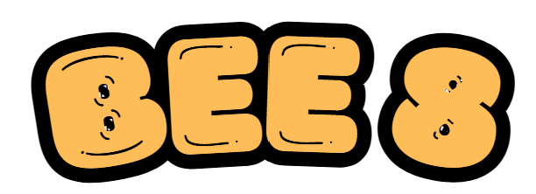
The context
A smart sensor has collected data from the Bee8 hive on Watling Street. Each reading records conditions such as outdoor temperature, hive temperature, hive humidity, pressure, battery level and weight. Your job is to use a sample of this data to make careful statistical inferences.

Learning intentions
• Choose a suitable sample from a large dataset.
• Calculate and interpret sample statistics such as the mean, standard deviation and sample proportion.
• Construct and interpret 95% confidence intervals for a population mean or proportion.
• Carry out and interpret a two-tailed z-test for a population mean.
• Write conclusions in context without overclaiming from the data.

Access the data
- Go to https://bee8.vercel.app/beehives.
- Select one Bee8 beehive to investigate.
- Download the data from the last 90 days.

LC Mathematics specification alignment
Course area | How this worksheet connects
Strand 1: Statistics and Probability | Students use data to investigate real questions and communicate conclusions.
Inferential statistics | Students use samples to make inferences about a larger set of readings.
Ordinary Level access | Sampling variability, margins of error for proportions, interpretation and limitations.
Higher Level extension | 95% confidence intervals for population means/proportions, two-tailed z-tests for population means and p-values.
Important statistical warning
The data can help us describe and make inferences about readings from this hive during this time period. It does not automatically prove what caused any pattern, and it does not automatically apply to every hive.

Part 1: Meet the dataset
Open the spreadsheet and identify the columns that may be useful for a statistical investigation.
Column name | What does it measure? | Possible use in an investigation
Temperature
Hive Temp
Hive Humidity
Weight

Part 2: Choose your research question
Tick one investigation question, or write your own.
☐ What is the mean hive temperature for a chosen month?
☐ What proportion of readings are above a chosen temperature?
☐ Is the mean hive temperature different from a claimed value?
☐ Do two months appear to have different average hive temperatures?
☐ Do day readings and night readings appear different?
____________________________________________________________________________________________________________________________________________________________________________________________________________________________________________________________________________________________
______________________________________________________________________________________________________________________________________________

Part 3: Sampling plan
Decision | Your answer
Population you are studying | Example: all Hive Temp readings collected in September
Variable | Example: Hive Temp
Sample size | Example: n = 50,
How you selected the sample | Example: random sample using Excel/Sheets RAND function
Why this method is better than using the first rows?
How to get a random sample in Google Sheets
Create a new column beside your data. Type =RAND() in the first row and fill down. Sort the sheet by this random column. Take the first n rows as your sample. If you need to keep the original order, work from a copy of the sheet.

Investigation A: Proportion of warm hive readings
For this investigation, define a warm hive reading as a Hive Temp reading above a threshold you choose. Suggested threshold: 25°C.
Formula box
Sample proportion: p̂$=\frac{x}{n}$
95% confidence interval for a population proportion: p̂ ± 1.96 $×\sqrt{\frac{\hat{p}(1-\hat{p})}{n}}$
Quick LC Ordinary Level margin of error approximation: $\frac{1}{\sqrt{n}}$

Value | Your work
Month or time period chosen
Threshold for warm reading | Hive Temp > ______ °C
Sample size, n
Number of warm readings, x
Sample proportion, p-hat
95% confidence interval

Write your conclusion in context
______________________________________________________________________________________________________________________________________________
______________________________________________________________________________________________________________________________________________
______________________________________________________________________________________________________________________________________________
______________________________________________________________________________________________________________________________________________
______________________________________________________________________________________________________________________________________________

Exam-style prompts
• Explain what your confidence interval means in the context of the hive.
• Would a larger sample size usually make the interval wider or narrower? Explain.
• Give one limitation of your conclusion.
______________________________________________________________________________________________________________________________________________
______________________________________________________________________________________________________________________________________________
______________________________________________________________________________________________________________________________________________
______________________________________________________________________________________________________________________________________________

Investigation B: Estimating mean hive temperature
Choose one month and take a random sample of Hive Temp readings. Use your sample to estimate the mean Hive Temp for that month in this dataset.
Formula box
95% confidence interval for a population mean: $\overline{x}$ ± 1.96 $×\frac{σ}{\sqrt{n}}$
where $\overline{x}$ is the sample mean, $σ$ is the sample standard deviation, and n is the sample size.

Quantity | Your value / working
Month chosen
Variable | Hive Temp
Sample size, n
Sample mean, $\overline{x}$
Sample standard deviation, $σ$
Standard error, $\frac{σ}{\sqrt{n}}$
95% confidence interval

Interpretation
In words, my interval means:
______________________________________________________________________________________________________________________________________________
______________________________________________________________________________________________________________________________________________
_________________________________________________________________________________________________________________
One reason the interval might not perfectly represent the hive is:
______________________________________________________________________________________________________________________________________________
______________________________________________________________________________________________________________________________________________
_________________________________________________________________________________________________________________

Investigation C: Testing a claim about the mean
A beekeeper claims that the mean Hive Temp for last August is 20°C. Use a one sample z-test at the 5% level of significance to test this claim. Using a random sample of August Hive Temp readings, test the claim that the mean Hive Temp for last August was 20°C.
Formula box
Null hypothesis: $H_{0}$: $μ=$
Alternative hypothesis: $H_{1}$: $μ≠$

Step | Your work
1. State $H_{0}$:
2. State $H_{1}$:
3. Sample size, n
4. Sample mean, x-bar
5. Standard deviation, $σ$
6. Calculate z score
7. Decision: reject or fail to reject H0?
8. Conclusion in context

P-value interpretation
Find the p-value, and explain what it means in this context.
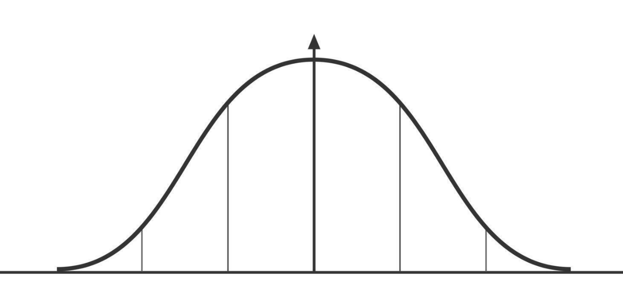

______________________________________________________________________________________________________________________________________________
______________________________________________________________________________________________________________________________________________
______________________________________________________________________________________________________________________________________________
______________________________________________________________________________________________________________________________________________
______________________________________________________________________________________________________________________________________________

Investigation D: Comparing groups
Choose one comparison. You are not required to do a formal two-sample test. Construct confidence intervals and compare them carefully.
☐ August Hive Temp vs October Hive Temp
☐ Day readings vs night readings
☐ Outdoor Temperature vs Hive Temp stability
☐ Two different hives, if available
Quantity | Group 1 | Group 2
Group name
Sample size
Sample mean
Standard deviation
95% confidence interval
What do you notice?
Cautious conclusion
Be precise
Say “the sample suggests...” or “there is evidence in this data...” rather than making a claim that the data cannot prove. Good statistics is careful, not dramatic.

Extension: relationship between outdoor temperature and hive temperature
• Create a scatterplot of Temperature against Hive Temp.
• Describe the relationship.
• Calculate the correlation coefficient if your teacher asks for it.
• Explain why correlation does not prove that one variable caused the other.
______________________________________________________________________________________________________________________________________________
______________________________________________________________________________________________________________________________________________
______________________________________________________________________________________________________________________________________________
______________________________________________________________________________________________________________________________________________

Teacher notes: suggested use
Recommended structure
This works well as a set of lessons on data analysis or as a mini-project for TY/LC maths. Students can work in pairs: one student manages the spreadsheet and the other records the statistical reasoning. Keep the focus on context, sampling and interpretation, not just button pressing.

Suggested differentiation
Route | Suitable for | Main task
Ordinary Level | Core LC access | Warm-reading proportion and margin of error
Higher Level | Standard HL inferential statistics | Confidence interval for mean and two-tailed z-test
Extension | Strong HL / project work | Compare groups, discuss causation, graph relationships

Specification alignment detail
• Use data to answer a contextual question and communicate findings.
• Recognise sampling variability: two students may get different sample means from different random samples.
• Use sample statistics to estimate unknown population values.
• Construct and interpret 95% confidence intervals for proportions and means.
• For Higher Level, perform a two-tailed z-test for a population mean and interpret p-values.
• Discuss limitations such as sensor position, one-hive context, non-random time effects and correlation not proving causation.

Teacher prompt questions
What is the population in your investigation: all bees, all hives, or all readings in this spreadsheet?
Why might the first 100 rows be a biased sample?
What would change if the sensor was near the edge of the hive rather than the centre?
What extra data would help you explain why a temperature pattern happened?
What is the difference between “the data shows” and “the data proves”?

Optional spreadsheet formulas
Purpose | Formula / method
Random number for sampling | =RAND()
Sample mean | =AVERAGE(range)
Sample standard deviation | =STDEV.S(range)
Count readings above a threshold | =COUNTIF(range,">25")
Sample size | =COUNT(range)
Correlation coefficient | =CORREL(range1, range2)
Filter dates or times | Use Data > Create a filter, or create helper columns for month/hour

